#### 

the Sandler Center in Virginia Beach is hosting the performance this year. TAO will be hosting a special event celebrating the season on Wednesday, Dec. 14 at 7 p.m. The event will be an Open Mic & Jam held at the restaurant Tapped in Virginia Beach. Join BJ Griffin, Jason Brown, Mary Toboz, and several of the TAO staff and volunteers as they play, sing, and toast to the holidays. Songbooks and jingle bells will be available, and proceeds from the night will benefit TAO. Remember those family members during this time that may not be able to get out to enjoy the festivities, and bring that guitar or CD along when you visit to spread a little cheer.

Sleigh bells are ringing, the smell of food is in the air, and pictures of family and friends gathered together under one roof are beginning to float in our heads. Amongst the routine of the season, jingle things up a bit by bringing the arts into your home or involving them in your community outings.

Here are a few suggestions of things to do at those infamous home parties or family reunions:

1. Grab a guitar, play the piano, or turn on a CD, then invite the generations to come together for a sing-a-long of beloved holiday tunes.
2. Split into teams and turn classic holiday songs into a memory game. Play a short piece of the song to see if anyone can guess the name, or chose a song and see how well the team recalls the lyrics.
3. To keep the younger generations a fun activity, set up a small crafts table where they can make a wreath out of puzzle pieces, a snowman out of cotton balls, or color ornaments on cut out tree.

A classic family outing is going to see the Nutcracker ballet live, and

# ‘Tis the Season to be Singing

# How to make the arts a part of your holidays.

within their communities. It also creates an opportunity for nonprofit, civic, and other organizations to collaborate and inspire small acts of kindness. Funds raised by TAO this year will contribute to continuing its mission of spreading the healing power of the arts to those with special needs and circumstances. To find out more about #GivingTuesday, and TAO’s involvement, visit our homepage on Facebook.

Grants manager Julie Clark spreading the word on social media.

After you shop til you drop during one of the busiest retail weekends of the year, there will be one more box to check off on your Christmas list. The Tuesday following Black Friday and Cyber Monday is known as #GivingTuesday, a globally recognized day to kick off the giving season by donating to your favorite charities. The social media driven event encourages people to share their time and talents in order to come together, give, and help

#GIVINGTUESDAY

A global invitation to an online event.

In this issue:

* Arts in you holidays
* #GivingTuesday
* Artist Highlight
* Recent Study???
* 2016 at a glance

Nov./Dec. 2016 Issue

heARTstrings

University, and a pilot project of 134 pieces of art, thanks to the students and artists, is now installed at agencies such as the Ronald McDonald House and ForKids, Inc.

There are projects in the works for the coming year, and TAO would be thrilled to have more volunteer participation than ever in the coming year. To find out more about upcoming events for volunteer opportunities, visit www.tidewaterartsoutreach.org for more information.

TAO is finishing this year on a high note with what the tides brought in over the past ten months. A landmark was achieved, new events were introduced, instruments were painted, and new artists came into the limelight.

The organization reached its 2500th program milestone in May, and it “is a testament to the power of the arts to profoundly impact life at any age,” stated Executive Director Mary Toboz. The plans to reach the next 2500 programs have already begun, and any donations will help to ensure the programs reach even further into the communities.

This past year included 275 local artists, 5,766 program participants, and over 400 volunteers. The coming year creates a need for community volunteers, particularly program hosts who will see first hand the impact of TAO.

The need is also created by the special events to be hosted in 2017. The Instruments of Art and the Sea Level Singer/Songwriter Festival are both returning to the TAO calendar, and entries into the Instruments of Art are currently being accepted. The Sea Level Singer/Songwriter Festival will be held in the spring.

Last year’s Emerging Artist Contest winner, Andy Geels, went on this year to open for Grammy artist Pat Donohue and says that he has a couple of new albums on their way in 2017. Geels recently shared, “that winning was a genuine thrill for me. I was a finalist in 2015, so it was exciting to work hard, come back the next year, and win the whole thing.”

TAO also recently partnered with students from Old Dominion

This year marks the 5th anniversary of Arthur Lopez’s musical journey with TAO. He performs monthly in our programs at various locations and brings different types of drums for participants to learn about and play.

Lopez found a passion for the drums when he was 7 years old. He held on to that passion for 30 years while he worked in television production, but his true calling can be heard now as a drum circle/rhythm event facilitator.

Lopez studied jazz, Latin jazz, and Taiko drumming, and continues his study of West African drumming with various artists, including with the director of the Suwabi African Ballet in Norfolk, Va.

Training programs, challenge certifications, and workshops have been a continuous part of Lopez’s musical career. In 2009, he formed the Virginia World Rhythm Drum Circle, and in 2011, he created Drum Your Dream, a service that provides drum sessions at festivals, schools corporations, and works with the facilities that TAO serves.

In the fall of 2012, Lopez stated that he “gathered over 150 drummers” to create the largest drum circle that has been attempted throughout the world. He has a mission to bring communities together through music and to share his passion with other’s who can benefit from the freedom and joy of drumming.

TAO celebrates Lopez’s five years with the organization and continuously looks to him to uphold the mission of sharing the joy and healing power of the arts.

# Waves of Notes on 2016

# TAO highlights from the past year and how it is rolling into the next.

# .

The Benefits of Music for Both the Young and Young at Heart.

There have been studies done that agree that the arts have healing and coping benefits to those who are older in age, but what about the younger generation who are just beginning to learn? Here are some of the reasons why starting music appreciation at a young age could make an impact:

1. A recent study showed that certain motor and listening skills showed advancement when combined with musical experiences.
2. There have been several studies that show music can have an impact on academia in children.
3. Certain character trait developments have been attributed to musical study.

There is a 4-year-old son of one of TAO’s supporters that certainly shows signs of these studies being accurate. This child has shown a heightened since of awareness to musical changes, enjoys problem solving, and has had advanced motor skills since he started walking at an early age. The two generations could certainly learn a lot from each other.

This year marks the 5th anniversary of Arthur Lopez’s musical journey with TAO. He performs monthly in our programs at various locations and brings different types of drums for participants to learn about and play.

Lopez found a passion for the drums when he was 7 years old. He held on to that passion for 30 years while he worked in television production, but his true calling can be heard now as a drum circle/rhythm event facilitator.

Lopez studied jazz, Latin jazz, and Taiko drumming, and continues his study of West African drumming with various artists, including with the director of the Suwabi African Ballet in Norfolk, Va.

Training programs, challenge certifications, and workshops

He Can’t Stop the Beat

Artist highlight of the month is Arthur Lopez.

have been a continuous part of Lopez’s musical career. In 2009, he formed the Virginia World Rhythm Drum Circle, and in 2011, he created Drum Your Dream, a service that provides drum sessions at festivals, schools corporations, and works with the facilities that TAO serves.

In the fall of 2012, Lopez states that he “gathered over 150 drummers” to create the largest drum circle that has been attempted throughout the world. He has a mission to bring communities together through music and to share his passion with other’s who can benefit from the freedom and joy of drumming.

TAO celebrates Lopez’s five years with the organization and continuously looks to him to uphold the mission of sharing the joy and healing power of the arts.

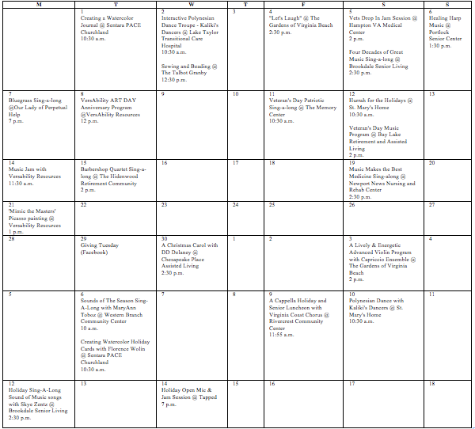

COMM 308

Old Dominion University

Professor Carol Branch

November & December calendar

809 Brandon Ave., Suite 300  
Norfolk, VA 23517

Tideawater Arts Outreach